BEAKERS - ACID-BASE

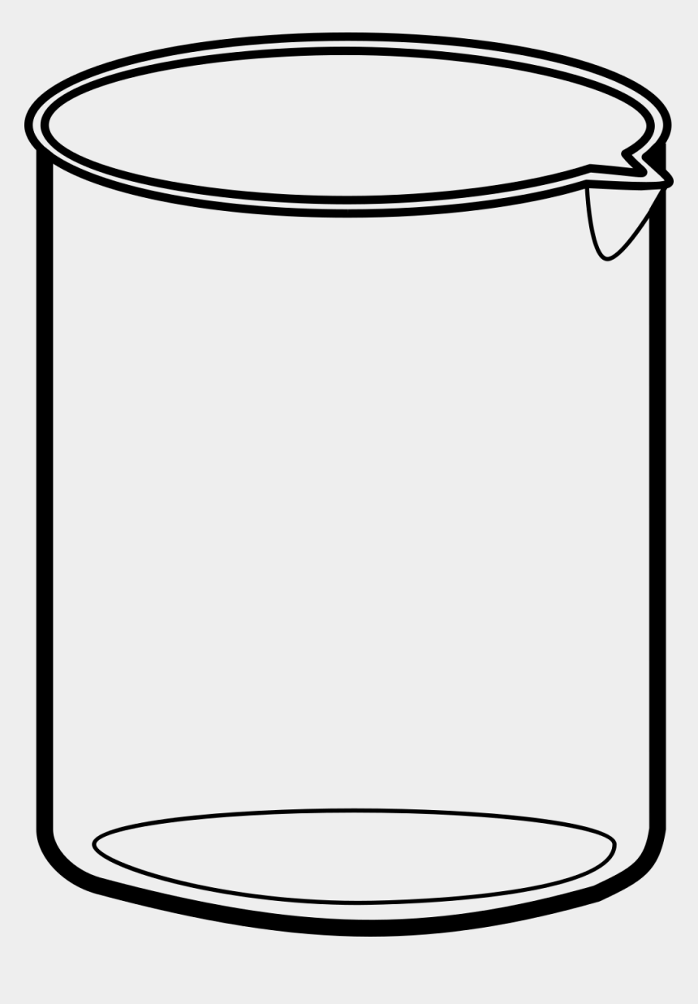
B
50.0 mL of
0.30M HC₂H₃O₂
A
30.0 mL of
0.20M NaOH

D
30.0 mL of
0.20M HCl
C
50.0 mL of
0.40M NH₄Cl

J
75.0 mL of
0.20M HCl
E
37.5 mL of
0.20M HCl

G
75.0 mL of
0.20M NaOH
F
50.0 mL of
0.30M NH₃

I
90.0 mL of
0.20M NaOH
H
37.5 mL of
0.20M NaOH

K
90.0 mL of
0.20M HCl
J
75.0 mL of
0.20M HCl

B
50.0 mL of
0.30M HC₂H₃O₂
B
50.0 mL of
0.30M HC₂H₃O₂

B
50.0 mL of
0.30M HC₂H₃O₂
B
50.0 mL of
0.30M HC₂H₃O₂

F
50.0 mL of
0.30M NH₃
F
50.0 mL of
0.30M NH₃

F
50.0 mL of
0.30M NH₃
F
50.0 mL of
0.30M NH₃

F
50.0 mL of
0.30M NH₃
F
50.0 mL of
0.30M NH₃

